UID lab 3

(chunking)

**Page 1:**

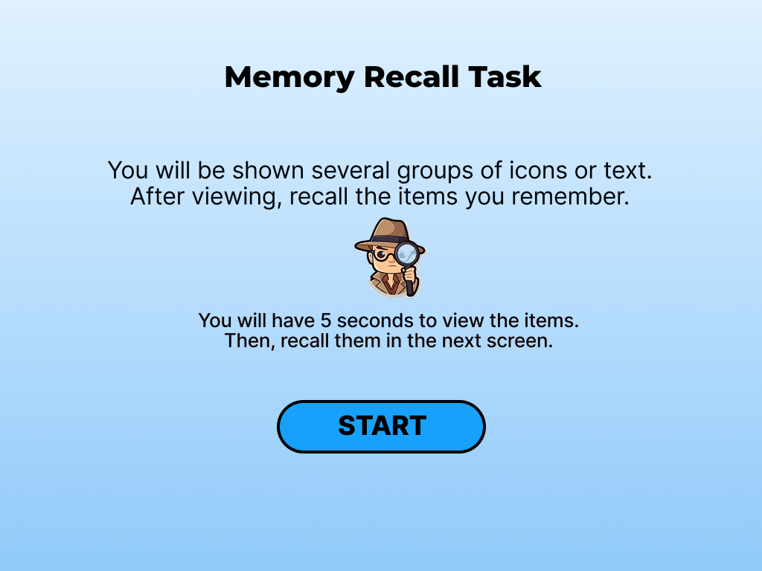

Here the user will be given the instructions and when the user presses the start button the memory recall task navigates to the next page , here except the start button all other information are just displayed to the user.

**Page 2:**

In page 2 the user is shown with all the images that he/she has to remember in the given 5 seconds so to show that to the user a timer is kept in the bottom of the screen and the images are just shown for only 5 seconds after that it navigates to the next page

The images are chunked into 3 segments and given for remembering.

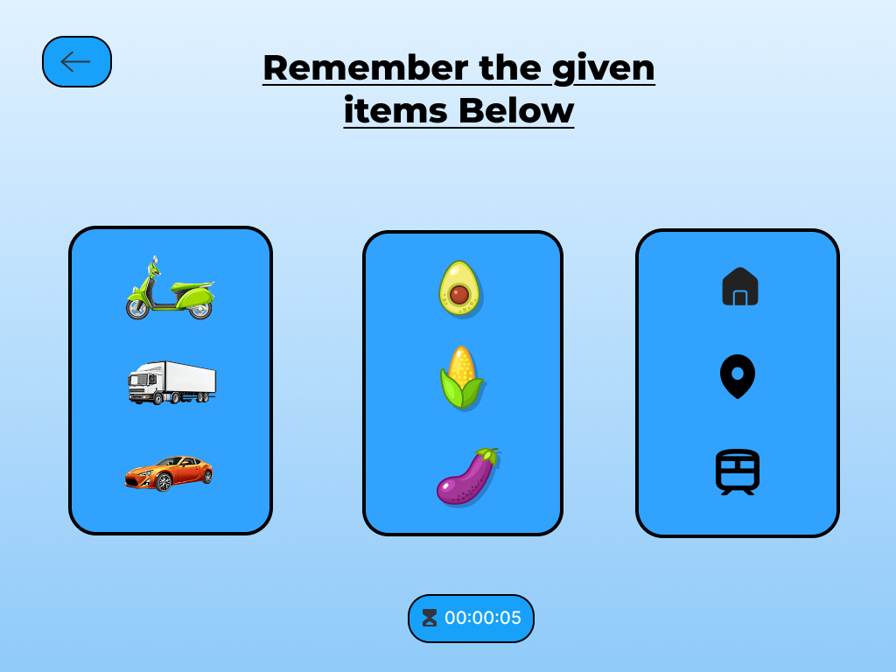

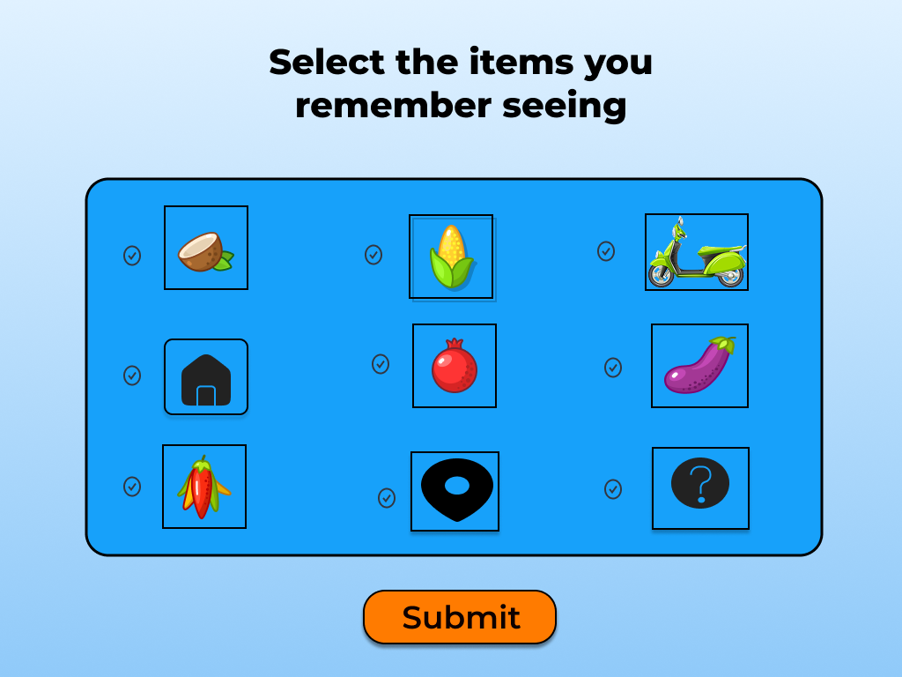**Page 3:**

In page 3, not only the images in page 2 are available but also some extra images are given to confuse the user in the remembering task.

selection icons are given so that the user can select the images that they remember and check their marks.

**Page 4:**

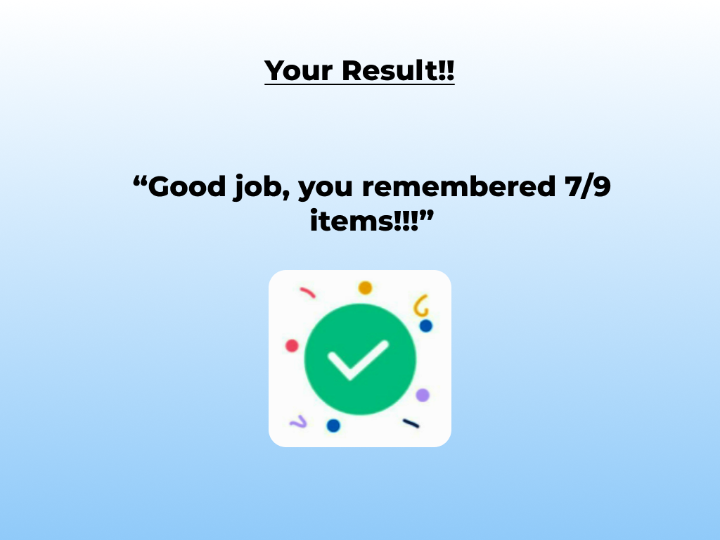

Based on the selected items the score will be given to the user and the score will be displayed on the screen.